**ASSIGNMENT-1(NALAIYA THIRAN)**

**SMART HOME DESIGN USING TINKERCAD**

**TEAM MMEMBER-1:M.Nivetha**

**REGISTER NUMBER:720319106015**

**SCHEMATIC:-**

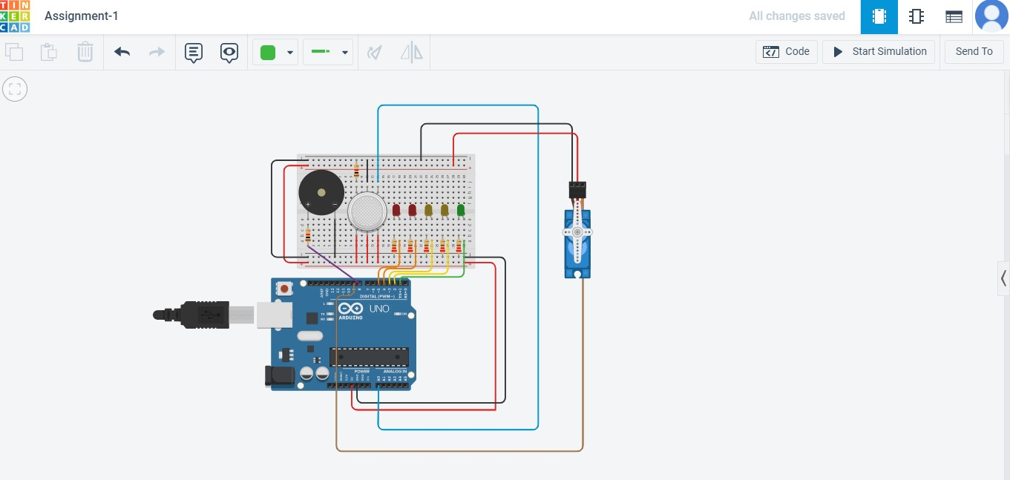

**CODING:**

#include <Servo.h>

Servo myservo;

#define ledR2 5

#define ledR1 4

#define ledY2 3

#define ledY1 2

#define ledG1 1

#define gas A0

#define buzzer 8 #define serv 9 void setup()

{

pinMode(ledR1, OUTPUT); pinMode(ledR2, OUTPUT); pinMode(ledY1, OUTPUT); pinMode(ledY2, OUTPUT); pinMode(ledG1, OUTPUT); pinMode(buzzer,OUTPUT); myservo.attach(serv); pinMode(gas, INPUT);

Serial.begin(9600);

}

void loop()

{

int read= analogRead(gas); int val= map(read,80,380,0,100); Serial.println(val); int servo= map(read,80,380,0,180); myservo.write(servo) digitalWrite(ledG1, HIGH); if(val>=20 && val<40){ digitalWrite(ledY1,HIGH);

}

if(val>=40 && val<60){ digitalWrite(ledY2,HIGH);

}

if(val>=60 && val<80){ digitalWrite(ledR1,HIGH);

}

if(val>=80){ digitalWrite(ledG1, HIGH); digitalWrite(ledY1, HIGH); digitalWrite(ledY2, HIGH); digitalWrite(ledR1, HIGH); digitalWrite(ledR2, HIGH); delay(500); digitalWrite(ledG1, LOW); digitalWrite(ledY1, LOW); digitalWrite(ledY2, LOW); digitalWrite(ledR1, LOW); digitalWrite(ledR2, LOW); delay(1000) tone(buzzer,1000,500);

}

if (val<80){ noTone(buzzer);

}

}